Ex.no:3 | DATA CLEANING

Aim:

Algorithm:
Check Missing Values:
- Start.
- Import the pandas library.
- Load the dataset into a DataFrame (df).
- Display dataset information using df.info().
- Check missing values using df.isnull().
- Count missing values using df.isnull().sum().
- Check missing values using df.isna().
- Check non-missing values using df.notnull().
- Display the results.

Drop Missing Values
- Start.
- Import the pandas library.
- Load the dataset into a DataFrame (df).
- Drop missing rows using dropna().
- Drop rows (axis=0) or columns (axis=1).
- Use how='any' to remove rows/columns containing any missing value.
- Use how='all' to remove rows/columns only if all values are missing.
- Use thresh=N to keep rows/columns with at least N non-missing values.
- Use subset=['column_name'] to drop rows based on specific columns.
- Use inplace=True to modify the original DataFrame.
- Display the cleaned DataFrame.

Program:
# ============================================================
# EXPERIMENT 3 - DATA PREPROCESSING
# WORLD HAPPINESS DATASET 2015-2024
# ============================================================

# ============================================================
# 1. IMPORT DATASET DIRECTLY FROM KAGGLE
# ============================================================

!pip install -q kagglehub

import kagglehub
import pandas as pd
import glob
import os

# Download directly from Kaggle
path = kagglehub.dataset_download(
"yadiraespinoza/world-happiness-2015-2024"
)

print("Dataset downloaded successfully!")
print("Path:", path)

# ============================================================
# 2. FIND AND READ CSV FILES
# ============================================================

csv_files = glob.glob(
os.path.join(path, "**", "*.csv"),
recursive=True
)

print("\nCSV Files:")
for file in csv_files:
print(os.path.basename(file))

# Read all CSV files
dataframes = []

for file in csv_files:
temp = pd.read_csv(file)

# Store source/year
temp["Year_File"] = os.path.basename(file)

dataframes.append(temp)

# Combine all years
df = pd.concat(
dataframes,
ignore_index=True
)

print("\nFirst 5 rows:")
print(df.head())

print("\nShape:")
print(df.shape)

# ============================================================
# 3. CHECK MISSING VALUES
# ============================================================

print("\nMissing Values:")
print(df.isnull())

print("\nTotal Missing Values:")
print(df.isnull().sum())

# ============================================================
# 4. HANDLE MISSING VALUES
# ============================================================

# Find categorical columns
categorical_columns = df.select_dtypes(
include=["object"]
).columns

# Fill categorical missing values with mode
for col in categorical_columns:

if df[col].isnull().sum() > 0:

df[col] = df[col].fillna(
df[col].mode()[0]
)

# Find numerical columns
numerical_columns = df.select_dtypes(
include=["int64", "float64"]
).columns

# Fill numerical missing values with median
for col in numerical_columns:

if df[col].isnull().sum() > 0:

df[col] = df[col].fillna(
df[col].median()
)

print("\nMissing values after preprocessing:")
print(df.isnull().sum())

# ============================================================
# 5. CHECK DUPLICATES
# ============================================================

print("\nDuplicate Records:")
print(df.duplicated())

print("\nNumber of duplicate records:")
print(df.duplicated().sum())

# Remove duplicates
df.drop_duplicates(
inplace=True
)

print("\nDataset after removing duplicates:")
print(df)

# ============================================================
# 6. OUTLIER DETECTION USING IQR
# ============================================================

# Find a happiness score column

if "Life Ladder" in df.columns:

score_column = "Life Ladder"

elif "Ladder score" in df.columns:

score_column = "Ladder score"

elif "Happiness Score" in df.columns:

score_column = "Happiness Score"

else:

score_column = None

# Detect outliers
if score_column is not None:

Q1 = df[score_column].quantile(0.25)

Q3 = df[score_column].quantile(0.75)

IQR = Q3 - Q1

lower = Q1 - 1.5 * IQR

upper = Q3 + 1.5 * IQR

outliers = df[
(df[score_column] < lower) |
(df[score_column] > upper)
]

print("\nOutliers in", score_column, ":")

print(outliers)

# ============================================================
# 7. NORMALIZATION USING MINMAXSCALER
# ============================================================

from sklearn.preprocessing import MinMaxScaler

scaler = MinMaxScaler()

# Select numerical columns
num_cols = df.select_dtypes(
include=["int64", "float64"]
).columns

# Apply Min-Max scaling
df[num_cols] = scaler.fit_transform(
df[num_cols]
)

print("\nNormalized Numerical Columns:")
print(df[num_cols].head())

# ============================================================
# 8. LABEL ENCODING
# ============================================================

from sklearn.preprocessing import LabelEncoder

encoder = LabelEncoder()

# Encode Country column
if "Country name" in df.columns:

df["Country name"] = encoder.fit_transform(
df["Country name"].astype(str)
)

elif "Country" in df.columns:

df["Country"] = encoder.fit_transform(
df["Country"].astype(str)
)

print("\nAfter Label Encoding:")
print(df.head())

# ============================================================
# 9. ONE-HOT ENCODING
# ============================================================

# Encode Year_File using One-Hot Encoding

one_hot = pd.get_dummies(
df["Year_File"],
prefix="Year"
)

print("\nOne-Hot Encoded Year:")
print(one_hot.head())

# Add one-hot columns to dataset
df = pd.concat(
[df, one_hot],
axis=1
)

# Remove original Year_File column
df.drop(
"Year_File",
axis=1,
inplace=True
)

print("\n===================================")
print("FINAL PREPROCESSED DATASET")
print("===================================")

print(df.head())

print("\nFinal Shape:")
print(df.shape)

print("\nRemaining Missing Values:")
print(df.isnull().sum())

print("\nFinal Dataset Information:")
df.info()

Output:
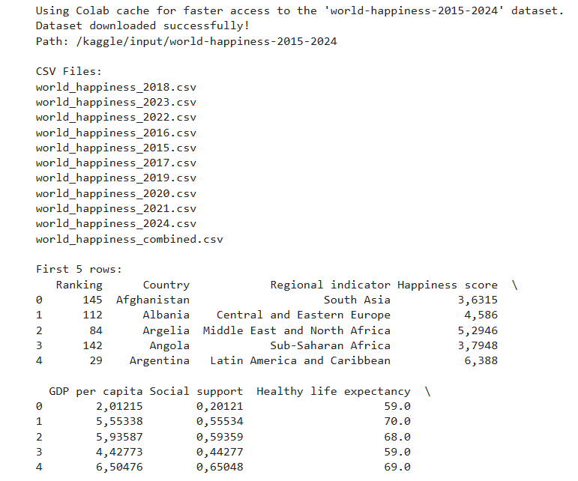
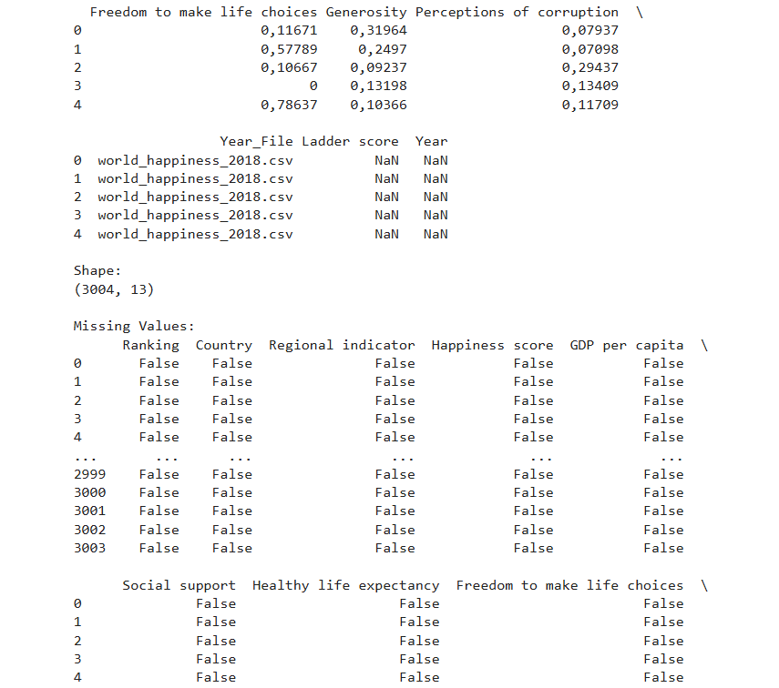
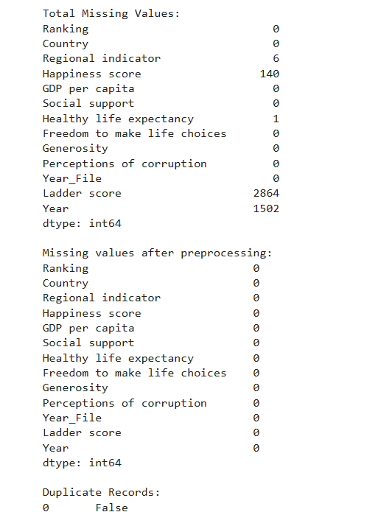

Result:

